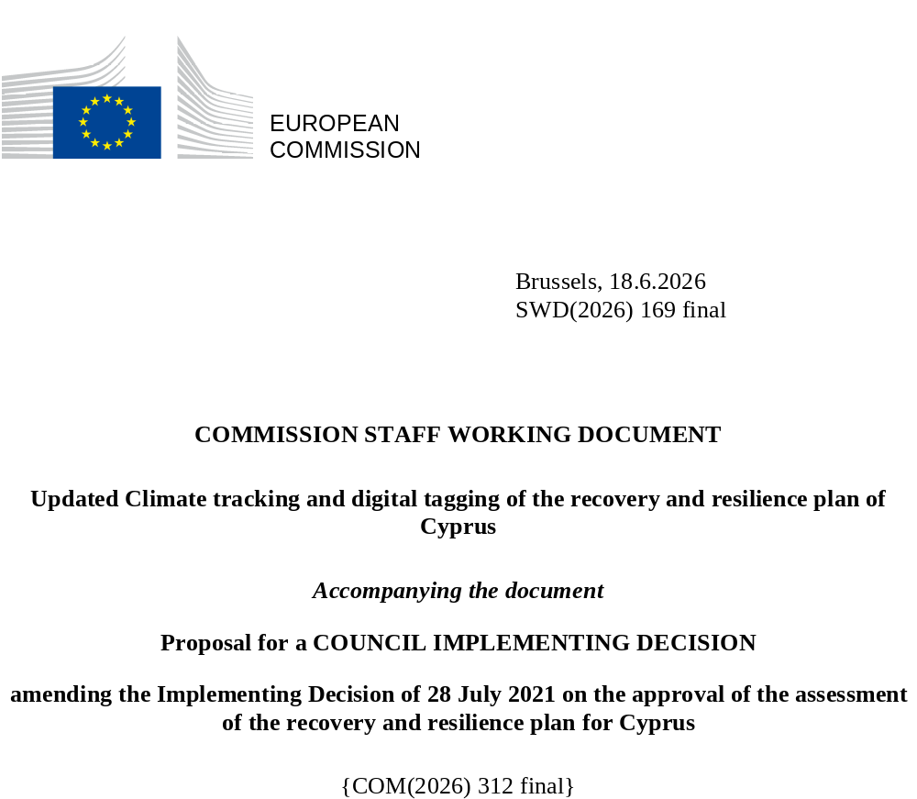

Updated climate tracking and digital tagging of the recovery and resilience plan of Cyprus
The table below presents the detailed application of the climate tracking and digital tagging methodologies set out respectively in Annexes VI and VII to Regulation (EU) 2021/241 in the modified Cypriot recovery and resilience plan.
Int. Field = intervention field.
Coeff. = Coefficient for the calculation of support to climate change objectives and to digital transition, on the basis of Annex VI and Annex VII of the RRF Regulation.
Revised measures are marked in yellow to distinguish them from the unchanged measures in the RRP.
Measure/ Sub-Measure ID | Measure/Sub-Measure Name | Budget (EUR m) | Climate |  | Digital
Measure/ Sub-Measure ID | Measure/Sub-Measure Name | Budget (EUR m) | Int.  Field | Coeff. % | Int.  Field | Coeff. %
C1.1R2 | Electronic platform for the surveillance of Nosocomial Antibiotic Consumption and Healthcare-Associated Infections | 0.40 |  |  | 095 | 100%
C1.1R1.1 | National Centre for Clinical Evidence and Quality Improvement - Digital platform | 1.00 |  |  | 095 | 100%
C1.1I1.1 | Cyprus Blood Establishment - Construction of new buildings | 5.22 | 025ter | 40%
C1.1I2 | Cyprus public health information system | 5.70 |  |  | 095 | 100%
C1.1I6 | Generic cross border e-health services in Cyprus | 1.94 |  |  | 013 | 100%
C1.1I7 | Public warning system for emergency operations | 4.50 | 036 | 100% | 055 | 100%
C1.1I5.1 | Construction works and new equipment in Cyprus State Hospitals - Construction of new buildings [Haemodyalisis unit at Paphos Hospital and new Mental Health Hospital] | 17.06 | 025ter | 40%
C1.1I5.2 | Construction works and new equipment in Cyprus State Hospitals - Energy efficient renovation | 34.74 | 026 | 40%
C1.1I5.3 | Construction works and new equipment in Cyprus State Hospitals - Digitalisation in Health Care | 27.72 |  |  | 095 | 100%
C2.1R3 | Digital One-Stop Shops to streamline RES projects permitting and to facilitate Energy Renovation in Buildings | 0.50 | 011bis | 40% | 011bis | 100%
C2.1I1 | Energy-saving investments in SMEs and non-profit organisations | 40.00 | 024ter | 100%
C2.1I2 | Promoting renewables and individual energy efficiency measures in dwellings and tackling energy poverty in households with people with vulnerable electricity consumers | 36.98 | 025bis | 100%
C2.1I3 | Facilitating the transition of local communities towards climate investments | 3.51 | 026bis | 100%
C2.1I5.1 | Energy efficiency investments in public buildings - Schools & Fire Service | 8.35 | 026bis | 100%
C2.1I5.2 | Energy efficiency investments in public buildings - Nicosia Hospital & Water | 1.30 | 029 | 100%
C2.1I6 | Expansion of the renewable energy and smart grids testing infrastructure at the University of Cyprus | 1.59 | 033 | 100% | 033 | 40%
C2.1I7 | Mass installation by the Distribution System Operator (DSO) of Smart Metering Infrastructure (Advanced Metering Infrastructure) | 35.00 | 033 | 100% | 033 | 40%
C2.1I8 | Monitoring and reduction of GHG emissions in agriculture | 4.13 | 022 | 100%
C2.1I9 | Fire protection | 28.46 | 036 | 100%
C2.1I10 | Market Management System (MMS) to facilitate the opening of the electricity market to competition | 4.70 | 033 | 100% | 033 | 40%
C2.2R1 | Installation of an Intelligent Transport System using Digital Twin technologies | 4.00 | 076bis | 40% | 076bis | 100.00%
C2.2R2 | Entry into force of legal act(s) regarding electric vehicle (EV) recharging infrastructure | 0.20 | 073 | 100%
C2.2I1.1 | Sustainable Urban Mobility Projects (SUMP) and accessibility-enhancing measures - SUMP / Cycling Infrastructure & accessibility enhancing measures | 8.99 | 075 | 100%
C2.2I2 | Creation of electro-mobility infrastructure | 4.75 | 073 | 100%
C2.2I3.1 | Advance the use of Electric Vehicles (EVs)- new electric cars + PS vehicles (ZEV) | 46.34 | 074 | 100%
C2.2I3.2 | Advance the use of Electric Vehicles (EVs)- new electric cars + PS vehicles (ZEV) | 10.11 | ADHOC | 40%
C2.3R1 | Water Resource Management Reform | 0.74 | 040 | 40%
C2.3I2 | Water Treatment Plants | 6.02 | 040 | 40%
C2.3I3 | Integrated Monitoring and Control Management System for the Water Development Department’s infrastructure | 0 | 040 | 40% | 055 | 100%
C2.3I4.1 | Smart Water and Sewerage Networks Management - Larnaca Sewerage (digital) | 0.33 | 010ter | 100% | 010ter | 100%
C2.3I4.2 | Smart Water and Sewerage Networks Management - Larnaca Sewerage (solar) | 0.95 | 029 | 100%
C2.3I4.3 | Smart Water and Sewerage Networks Management - Larnaca Sewerage (energy efficiency) | 0.25 | 024 | 100%
C2.3I4.5 | Smart Water and Sewerage Networks Management - Larnaca & Limassol Waterboard / water management | 17.00 | 040 | 100% | 055 | 100%
C2.3I5 | Anti-flood and water collection measures | 27.88 | 035 | 40%
C2.3I6 | Water security projects | 12.87 | 037 | 100%
C3.1R2 | On-line platform for trade and information symmetry in the fresh produce supply chain | 0 |  |  | 011 | 100%
C3.1R3.1 | Genetic improvement of the Cyprus sheep and goat population- Digital | 0.20 |  |  | 011 | 100%
C3.1I2 | Support of isotopic database of Cypriot food or drink products | 1.00 |  |  | 011 | 100%
C3.1I7 | Scheme for the competitiveness and/or the energy efficiency of large enterprises in Cyprus | 7.00 | 024bis | 40%
C3.1I8 | Added value of tourism | 5.48 |  |  | 055 | 100%
C3.1I9 | Circular economy in hotels | 1.40 | 047 | 40%
C3.1I10.1 | Enrichment of tourism - Natural heritage | 1.80 | 050 | 40%
C3.1R4 | Circular economy | 10.56 | 047 | 40%
C3.1I12 | Waste management towards circular economy | 3.30 | 042 | 40%
C3.1I11 | Extension of the Cyprus Green Points Network | 9.73 | 047 | 40%
C3.2I2.1 | Innovation funding programmes - Green transition | 2.00 | 022 | 100%
C3.2I3 | R&I funding programme on green transition | 6.00 | 022 | 100%
C3.3I2 | A Regulatory Sandbox | 0.40 |  |  | 021ter | 100%
C3.3I4 | Scheme for the digital upgrade of enterprises | 10.00 |  |  | 010 | 100%
C3.3I1 | Integrated Information system for the Department of Registrar of Companies and Intellectual Property | 6.58 |  |  | 011 | 100%
C3.4R4.1 | Digitalisation of public procurement - Digital | 4.00 |  |  | 011 | 100%
C3.4R5 | Enhancement of the capacity of the Law Office | 1.03 |  |  | 011 | 100%
C3.4R7.1 | Urban land consolidation - Digital | 0.12 |  |  | 011 | 100%
C3.4I4 | E-system for issuing building permits | 1.12 |  |  | 011 | 100%
C3.4I5 | Smart cities | 22.50 | 055bis | 40% | 055bis | 100%
C3.4I6.1a | Regeneration and Revitalization of Nicosia Inner City - Renovation | 5.77 | 025 | 40%
C3.4R9 | Digital transformation of courts | 1.23 |  |  | 011quater | 100%
C3.5R6.1 | Reinforcing the insolvency framework - Digital | 0.60 |  |  | 011 | 100%
C3.5I1 | Enhancement of the Supervisory Function of the Cyprus Securities and Exchange Commission | 0.25 |  |  | 011 | 100%
C3.5R9.1 | Digitalising tax collection - Digital | 13.95 |  |  | 011 | 100%
C3.5I2 | Modernisation of Customs and Electronic Payment System | 10.58 |  |  | 011 | 100%
C4.1R1 | Empower the National Regulatory Authority (OCECPR) | 0.50 |  |  | 011 | 100%
C4.1I1 | Expansion of Very High Capacity Networks in underserved areas | 35.00 |  |  | 053 | 100%
C4.1I2 | Upgrade internet connection to be “Gigabit-ready” and support connectivity take-up | 10.00 |  |  | 053 | 100%
C4.2R1 | Digital Services Factory | 4.70 |  |  | 011 | 100%
C4.2R2 | New cloud policy with regard to government IT systems and services and infrastructure set-up | 5.96 |  |  | 011 | 100%
C4.2R3 | Police Procedures digitalisation (Digipol) | 8.00 |  |  | 011 | 100%
C4.2R4 | Setting up the beneficial ownership registry | 0.40 |  |  | 011 | 100%
C4.2I1.1 | Digitalisation of central government ministries/services | 13.10 |  |  | 011 | 100%
C4.2I2 | Digitalisation of the Cyprus Ports Authority | 3.68 |  |  | 011 | 100%
C5.1R4 | Digital transformation of school units with the aim of supporting digital skills and skills related to STEM education | 13.2 |  |  | 012 | 100%
C5.1R5 | E-skills Action Plan – Delivery of specific actions | 1.85 |  |  | 108 | 100%
C5.1I2.1 | Skilling, reskilling and upskilling - green skills | 2.58 | 01 | 100%
C5.1I2.2 | Skilling, reskilling and upskilling - digital skills | 8.42 |  |  | 108 | 100%
C5.2I1.1 | Supporting the Department of Labour and Public Employment Services (PES) and reinforcing support for young people - Digital | 2.28 |  |  | 011 | 100%
C5.2R1.1 | Reform of the Social Insurance System and Restructuring of the Social Insurance Services - Digital | 7.25 |  |  | 011 | 100%
C6.1I1 | Scaled-up measure: Renewables and individual energy efficiency measures in dwellings | 63.04 | 025bis | 100%
C6.1I5 | Scaled-up measure: Scheme for the competitiveness and the energy efficiency of large enterprises in Cyprus | 10.00 | 024bis | 40%
C6.1I6 | Scaled-up measure: Thematic research and innovation funding program on green transition | 5.40 | 022 | 100%
C6.1I3 | Promoting extensive energy upgrading of housing stock | 21.99 | 025bis | 100%
C6.1I7 | Thematic research in enterprises for energy production, storage, transmission and distribution solutions | 4.00 | 022 | 100%
C6.1R2 | Introduction of regulatory framework for the connection of EV recharging points to the distribution network | 0.06 | 073 | 100%

*Reforms and investments in the REPowerEU chapter are not taken into account when calculating the plan’s contribution to the digital target requirement set by Regulation (EU) 2021/241.

